Warm-Up: “Worse Than Slavery”

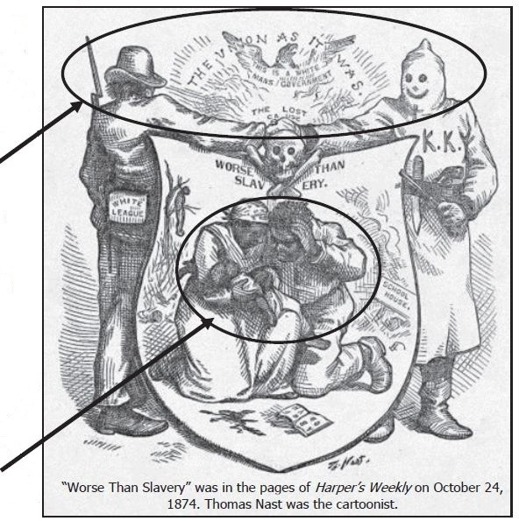
A
B

- What do the people at the top of the cartoon represent (A)?

- What do the people at the bottom of the cartoon represent (B)?

- What emotions are both groups showing in the cartoon?

- What did Thomas Nast think about Jim Crow laws and how blacks were treated after the Civil War? Provide two pieces of evidence from the cartoon?

